Predicting Student Failure in Distance Learning Using Machine Learning and Explainability
MSc Artificial Intelligence and Data Science
Final Research Project (Module 771764)

Name: Pius Twumasi
Student ID: 202374354
Supervisor: Dr Aoife Curran

August 2026.

Word Count: 5477
Faculty of Science and Engineering
University of Hull

Abstract
Background: Distance-learning modules record higher failure and withdrawal rates than campus study, and by the time a student formally fails, the window for support has usually closed. Institutions capture rich engagement data but rarely turn it into early, explainable warnings.
Aim: To develop and evaluate an interpretable machine-learning pipeline that identifies at-risk students early in a course and explains the drivers behind each prediction.
Dataset: The Open University Learning Analytics Dataset (OULAD), restricted to four Level-1 modules (BBB, DDD, EEE, FFF); 22,749 students were modelled after removing pre-census withdrawals.
Methods: A binary pass/fail target was defined with census-aware withdrawal handling, and all predictors were restricted to information available on or before the first assessment, a leakage-safe early-warning horizon. Three feature families (demographic, VLE engagement and first-assessment behaviour) were engineered. Four models, logistic regression, random forest, XGBoost and a regularised multilayer perceptron (MLP), were tuned under stratified cross-validation, comparing SMOTE with cost-sensitive weighting. Models were evaluated by area under the precision-recall curve (PR-AUC), explained with SHAP, and tested for cross-course transfer; an ablation withheld the first-assessment mark to isolate engagement's contribution.
Results: XGBoost was the strongest model, reaching a held-out PR-AUC of 0.877 on DDD and 0.829-0.877 across the four modules; the logistic regression model was within 0.02 PR-AUC on every course and won on EEE. Cross-validation variance was small (about ±0.005 to ±0.024), and test scores tracked cross-validation means. First-assessment and engagement features dominated the SHAP rankings, with four recurring in the top ten of all four courses, while demographics contributed little. Withholding the first-assessment mark reduced mean PR-AUC by only about 0.017, and cross-course transfer fell to 0.72-0.87.
Conclusions: Engagement and first-assessment behaviour support accurate, interpretable early identification of at-risk distance learners. The small ablation penalty suggests that the signal is broad rather than resting on a single predictor, and the leading drivers are stable across courses, but partial transfer means per-course validation remains necessary before deployment.

1. Introduction

1.1 Background
Online and distance higher education has expanded rapidly, yet it continues to record higher rates of failure and withdrawal than campus-based study (Levy, 2007; Rahmani et al., 2024). Learners work remotely, often part-time and around employment, and the informal cues that let a classroom tutor notice a struggling student are absent. By the time a student formally fails or withdraws, the opportunity for timely support has usually passed. Virtual learning environments (VLEs) now log detailed traces of students’ engagement, alongside assessment records and demographic data. Converting these traces into an accurate and timely signal of academic risk is the central promise of learning analytics (Rahmani et al., 2024), and the problem this project addresses. Such a signal is useful only if it is both early enough to act on and clear enough for a tutor to trust.

1.2 Related work
Predicting at-risk students from VLE data is a mature strand of learning analytics, and OULAD (Kuzilek et al., 2017) has become a common benchmark (Jin et al., 2024). Most work treats it as a binary classification of clickstream and assessment features. Aljohani et al. (2019) used a long short-term memory network on weekly clickstream data, separating pass from fail with around 90% accuracy by the tenth week, and Adnan et al. (2021) showed accuracy climbing as the course elapses, with assessment scores and clickstream intensity the most informative inputs. Gupta et al. (2022) reached AUC above 0.92 with an interpretable hidden Markov model over early-quarter assessments. Together, these studies establish that engagement data carries genuine predictive signal.
What they share is also their limitation. Most report performance well into the course: the LSTM result is a week-ten figure, and Adnan et al. (2021) report accuracy at 20%, 40% and later fractions of course length. The earlier the checkpoint, the more useful the warning and the harder the task, so mid-course results say little about how a genuinely early system would perform. Akçapınar et al. (2019) confirmed this tension, flagging unsuccessful students within the first three weeks but at markedly lower accuracy than later. A second limitation is interpretability: accuracy is often pursued through models whose decisions cannot be inspected, which suits a league table but not an early-warning tool, where a tutor needs to know why a student was flagged. Interest in explainable analytics has grown in response, with SHAP (Lundberg & Lee, 2017) used to attribute predictions to features (Sahlaoui et al., 2021). Working directly on OULAD, Oyedotun et al. (2025) combined a model with SHAP and found engagement features, especially total clicks, dominant while demographics contributed little, reaching a ROC-AUC of about 0.79. A third limitation is scope: models are usually trained and evaluated on a single course, so whether their patterns transfer to other courses is left untested. Dai et al. (2025) is a notable exception, showing that a model trained on one presentation could identify at-risk students in a later presentation of the same course, but transfer across different courses, where content and engagement rhythms differ, is rarely examined.

1.3 Contribution
This project addresses those three limitations; each addition is a deliberate step beyond a standard single-course classifier. First, it fixes an explicitly leakage-safe early-warning horizon at the first assessment, so no outcome information can leak into the predictors and reported performance reflects what a system could actually know then. Second, it pairs every prediction with a SHAP explanation at the global and individual level, so the model can be interrogated rather than merely trusted. Third, it tests cross-course generalisation, both by transferring a trained model between courses and by measuring whether the most important predictors recur. A controlled ablation withholding the first-assessment mark quantifies how much of the signal behaviour it carries, separating a genuinely predictive model from one that merely restates the first grade.

1.4 Aim and research questions
The aim is to develop and evaluate an interpretable machine-learning pipeline that predicts, early in a course, which distance-learning students risk failing, and explains the drivers of each prediction. Three research questions follow:
RQ1. How accurately can student failure be predicted from demographic, engagement and first-assessment data available at an early-warning checkpoint, and which model family performs best?
RQ2. Which factors most influence predicted risk, and how much of the predictive signal depends on the first-assessment mark?
RQ3. Do the predictive patterns generalise across different courses?

2. Approach

2.1 Dataset
OULAD contains 32,593 students across 22 module presentations at the Open University, combining demographic records, assessment results and daily VLE click summaries of more than 10.6 million interaction records (Kuzilek et al., 2017). Analysis was restricted to four Level-1 modules, BBB, DDD, EEE and FFF, chosen for their size and span of subject areas, which makes the RQ3 cross-course comparison meaningful. These comprise 24,877 students before target construction, modelled identically for comparison.

2.2 Target definition and early-warning horizon
The four OULAD outcomes were mapped to a binary target: Pass and Distinction as success, Fail as failure. Withdrawal was handled by census date. Students who withdrew before census (2,128 across the four modules) were removed as non-starters rather than academic failures; post-census withdrawals were treated as failures. This yielded 22,749 modelled students with an overall failure rate of 0.487, a near-balanced problem (class ratio about 1.1 to 1). The prediction horizon was fixed at each presentation's first assessment, and every predictor uses only information available on or before that date; cutoff days ranged from 12 to 33, reflecting genuine differences in when the first assignment falls (Figure 1). This makes the model a true early-warning system and removes the target leakage that arises when whole-course engagement predicts an end-of-course outcome.
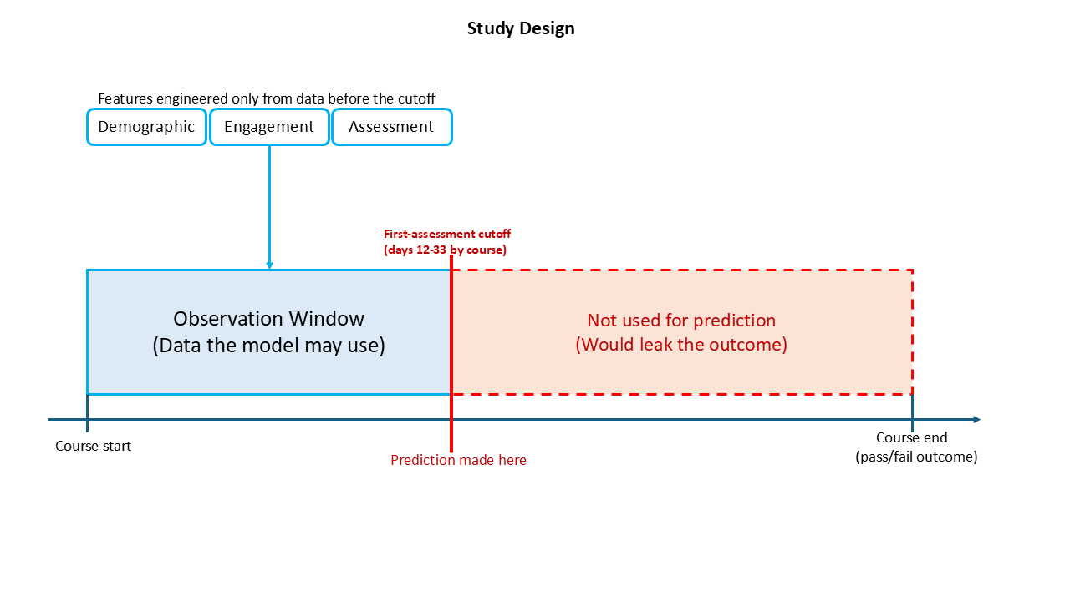Figure 1: Study design. Each course presentation has a first-assessment cutoff (day 12-33); only demographic, engagement and first-assessment data observed up to that cutoff enters the model, which predicts the end-of-course pass/fail outcome.

2.3 Feature engineering
Twenty-nine features were engineered across three families. Demographic features came from student records: gender, region, highest education, IMD band, age band, disability, prior attempts, studied credits and registration date. Engagement features summarised VLE clickstream activity up to the cutoff, including total clicks, active days, the active-to-elapsed-day ratio, first-week clicks, an engagement trend, days since last login, and counts of distinct sites and activity types (14 in total). First-assessment behaviour captured whether the first assignment was submitted, how early or late, the mark and a banded mark. All features were computed strictly within the early-warning horizon (Table 1), and two missing fields were imputed inside the horizon so no imputation could depend on later information.
Table 1: Engineered feature families.
Feature family | Features | Count
Demographic | gender, region, highest_education, imd_band, age_band, disability, num_of_prev_attempts, studied_credits, date_registration | 9
VLE engagement | vle_total_clicks, vle_active_days, vle_mean_clicks_active_day, vle_std_clicks_active_day, vle_max_clicks_day, vle_max_consecutive_days, vle_clicks_per_active_day, vle_days_since_last_login, vle_active_day_ratio, vle_first_week_clicks, vle_prestart_clicks, vle_engagement_trend, vle_distinct_sites, vle_distinct_activity_types | 14
First-assessment behaviour | a1_submitted, a1_score, a1_days_early, a1_late, a1_is_banked, a1_score_band | 6

2.4 Class imbalance
Although the pooled problem is near-balanced, per-course failure rates range from 40.0% to 54.7%, so imbalance handling was compared rather than assumed. For each model, three strategies were evaluated: no resampling, SMOTE (Chawla et al., 2002) and cost-sensitive class weighting. SMOTE was applied only within training folds, since oversampling before splitting leaks synthetic neighbours across it and inflates scores. Different courses and models favoured different strategies (Table 3).

2.5 Models and tuning
Four contrasting classifiers spanned the bias-variance and interpretability spectrum: logistic regression as a linear, transparent baseline; random forest (Breiman, 2001) and XGBoost (Chen & Guestrin, 2016) as tree ensembles capturing non-linear interactions; and a regularised multilayer perceptron (MLP) as a neural baseline. Comparing four families, rather than tuning one, tests whether added complexity is warranted here. Each was tuned by randomised search under five-fold stratified cross-validation. Scale-sensitive models (logistic regression, the MLP) received standardised numeric features and one-hot categoricals; tree models used the same features unscaled, since they split on raw thresholds. The MLP used two hidden layers (128 and 64 units) with dropout and early stopping, kept small because the data is modest and tabular.

2.6 Evaluation
Models were assessed on a held-out 20% test split, stratified by outcome and never used in tuning. The primary metric was area under the precision-recall curve (PR-AUC), which focuses on the positive (failure) class an early-warning system exists to catch. It provides a direct assessment of precision and recall for the positive class (Saito & Rehmsmeier, 2015); ROC-AUC and F1 are reported alongside for comparability. The PR-AUC standard deviation across folds is reported as a reliability measure, and cross-validation means are compared with test scores to assess potential overfitting.

2.7 Explainability
The best model per course was explained with SHAP (Lundberg & Lee, 2017), using a model-specific explainer where one was available and compatible, and a sampled, model-agnostic explainer otherwise. In the environment used here, XGBoost used the model-agnostic explainer; logistic regression used its exact linear explainer. Global mean absolute SHAP values ranked the drivers overall, and individual waterfall plots decomposed representative predictions (a true positive, false positive and false negative), showing how feature values pushed each above or below the base rate.

2.8 Cross-course design
Generalisation was tested two ways. A transfer matrix trained XGBoost on one course and evaluated it on each of the others, quantifying how much performance is lost away from the training course. Separately, a SHAP consistency check counted how many of the four courses placed each feature in its top ten, showing whether the same drivers recur even where absolute performance differs.

2.9 Reproducibility and implementation
The pipeline is implemented in Python using scikit-learn (Pedregosa et al., 2011), XGBoost, imbalanced-learn and SHAP, structured as modular stages (data loading, target construction, feature engineering, modelling, explanation and cross-course analysis) and packaged as a single documented notebook. It applies a range of techniques under one harness: stratified splitting, five-fold stratified cross-validation, randomised hyperparameter search, in-fold SMOTE, per-model imbalance selection and model-matched SHAP explainers. A fixed random seed governs all splits, resampling and initialisation, and every figure and table is produced directly by the notebook, so the code reproduces the reported results exactly.

3. Results

3.1 Cohort and class balance
The modelled cohort comprised 22,749 students. Failure rates varied by module, from 40.0% on EEE to 54.7% on DDD, with BBB at 46.8% and FFF at 49.3% (Table 2; Figure 2), confirming a near-balanced problem. Failure rates also varied across demographic groups (Figure 3): gender made little difference (female 48%, male 49%), but disability was associated with a higher rate (60% versus 48%), as was lower prior education (69% for no formal qualifications and 59% below A-level, against 32% for postgraduate-qualified students). Deprivation showed a clear gradient, from 62% failure in the most deprived IMD decile to 37% in the least. These disparities are examined further when interpreting fairness and implications (Sections 4.2 and 4.4).
Table 2: Modelled cohort by module: student counts, held-out test-set size and failure rate.
Module | Students | Test set | Failure rate
BBB | 7,052 | 1,411 | 46.8%
DDD | 5,757 | 1,152 | 54.7%
EEE | 2,751 | 551 | 40.0%
FFF | 7,189 | 1,438 | 49.3%
All four | 22,749 | n/a | 48.7%
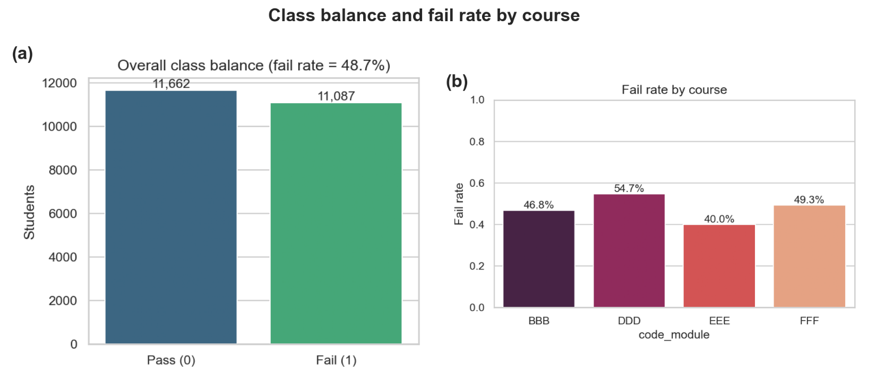Figure 2: Exploratory overview of the modelled cohort, showing overall class balance and failure rate by module.
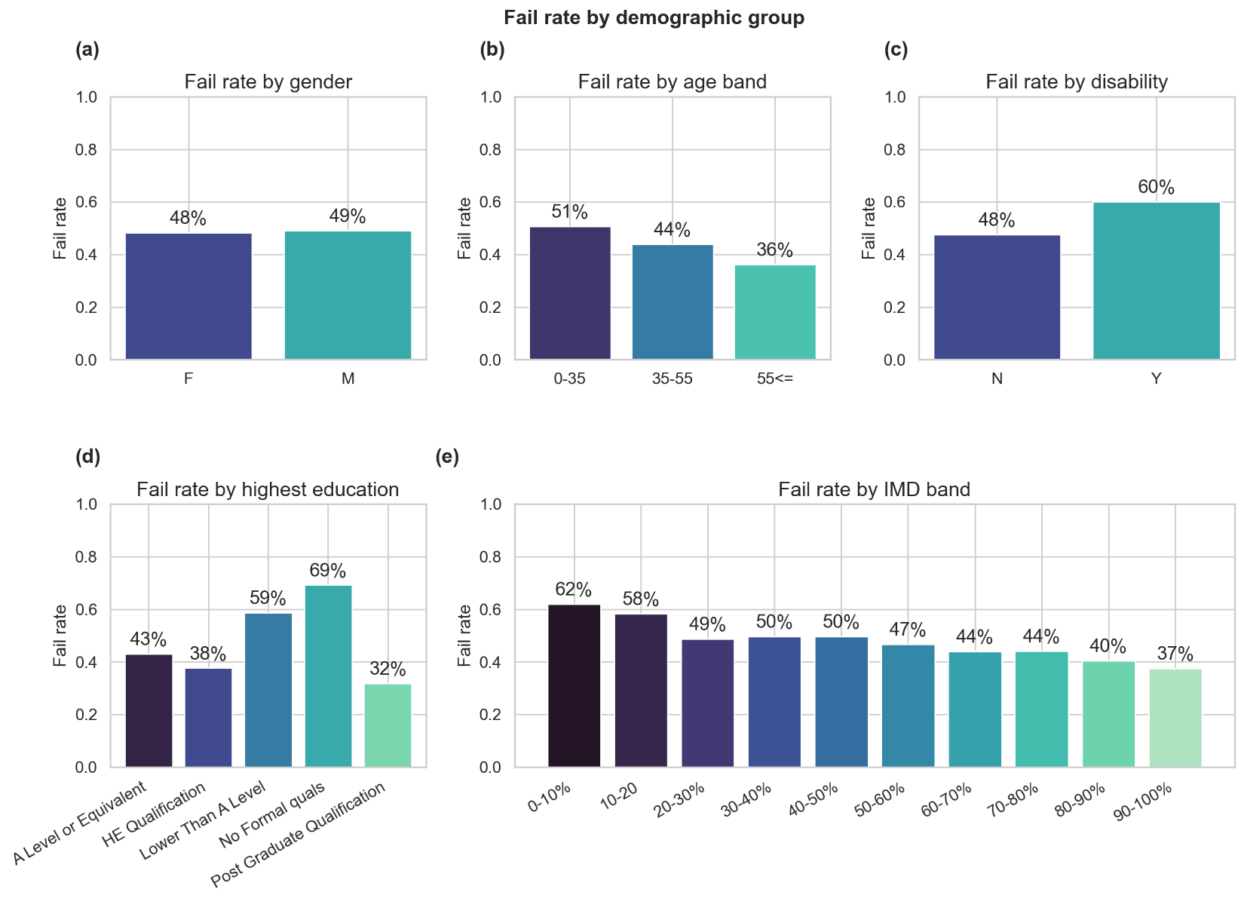Figure 3: Failure rate by demographic group (gender, age band, disability, highest education and deprivation band).

3.2 Predictive performance
All four models predicted failure well above chance at the first-assessment horizon. On the featured course DDD, XGBoost achieved the best held-out performance (PR-AUC 0.877, ROC-AUC 0.850, F1 0.770), narrowly ahead of logistic regression (0.870), random forest (0.865) and the MLP (0.861). Across the four modules XGBoost was strongest on three (DDD 0.877, BBB 0.829, FFF 0.834) and logistic regression on one (EEE 0.843); the full 16-model comparison, with each configuration's imbalance strategy, is in Table 3. Two patterns stand out. First, the four models are separated by at most about 0.02 PR-AUC within any course, so the interpretable linear model is genuinely competitive. Second, the confusion matrices make the operating point concrete: on DDD, XGBoost identified 449 of 630 failing students (recall 0.713) at precision 0.838, missing 181 and raising 87 false alarms (Figure 5). Precision-recall and ROC curves appear in Figure 4.
Table 3: Held-out performance of all four models on each module (first-assessment mark included). Rows are ordered by PR-AUC within each module, so the best model per module is the first row of each block.
Module | Model | PR-AUC | ROC-AUC | F1 | Strategy
BBB | XGBoost | 0.829 | 0.815 | 0.680 | none
BBB | MLP | 0.821 | 0.807 | 0.689 | none
BBB | Random forest | 0.816 | 0.803 | 0.660 | none
BBB | Logistic regression | 0.816 | 0.801 | 0.669 | none
DDD | XGBoost | 0.877 | 0.850 | 0.770 | class_weight
DDD | Logistic regression | 0.870 | 0.850 | 0.775 | none
DDD | Random forest | 0.865 | 0.838 | 0.759 | smote
DDD | MLP | 0.861 | 0.835 | 0.754 | none
EEE | Logistic regression | 0.843 | 0.857 | 0.697 | class_weight
EEE | MLP | 0.841 | 0.855 | 0.700 | class_weight
EEE | XGBoost | 0.834 | 0.845 | 0.686 | none
EEE | Random forest | 0.832 | 0.843 | 0.695 | smote
FFF | XGBoost | 0.834 | 0.810 | 0.711 | none
FFF | Logistic regression | 0.831 | 0.810 | 0.701 | class_weight
FFF | MLP | 0.830 | 0.804 | 0.708 | none
FFF | Random forest | 0.827 | 0.804 | 0.710 | class_weight

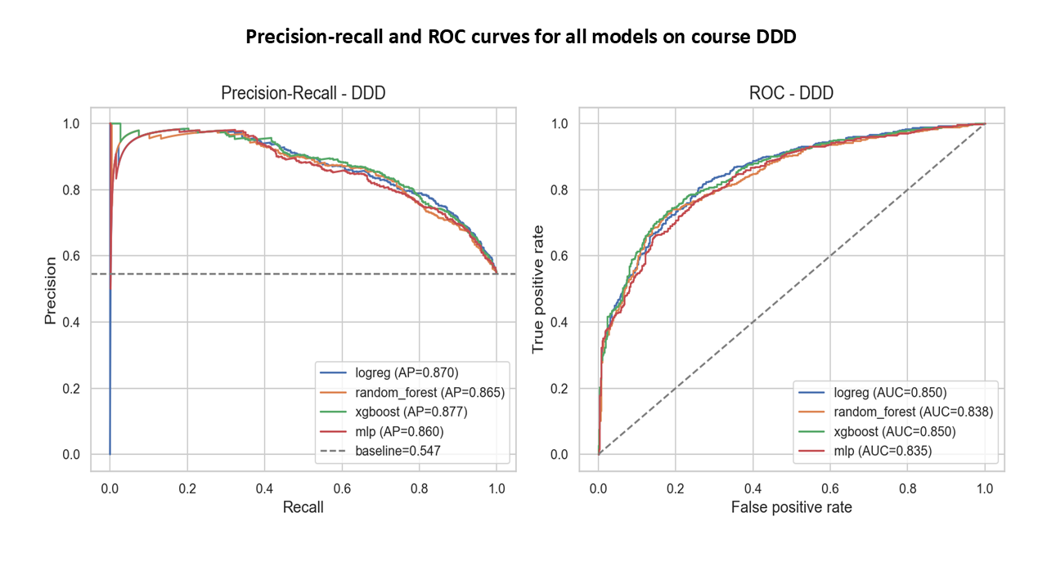Figure 4: Precision-recall and ROC curves for all four models on course DDD, with area-under-curve values.
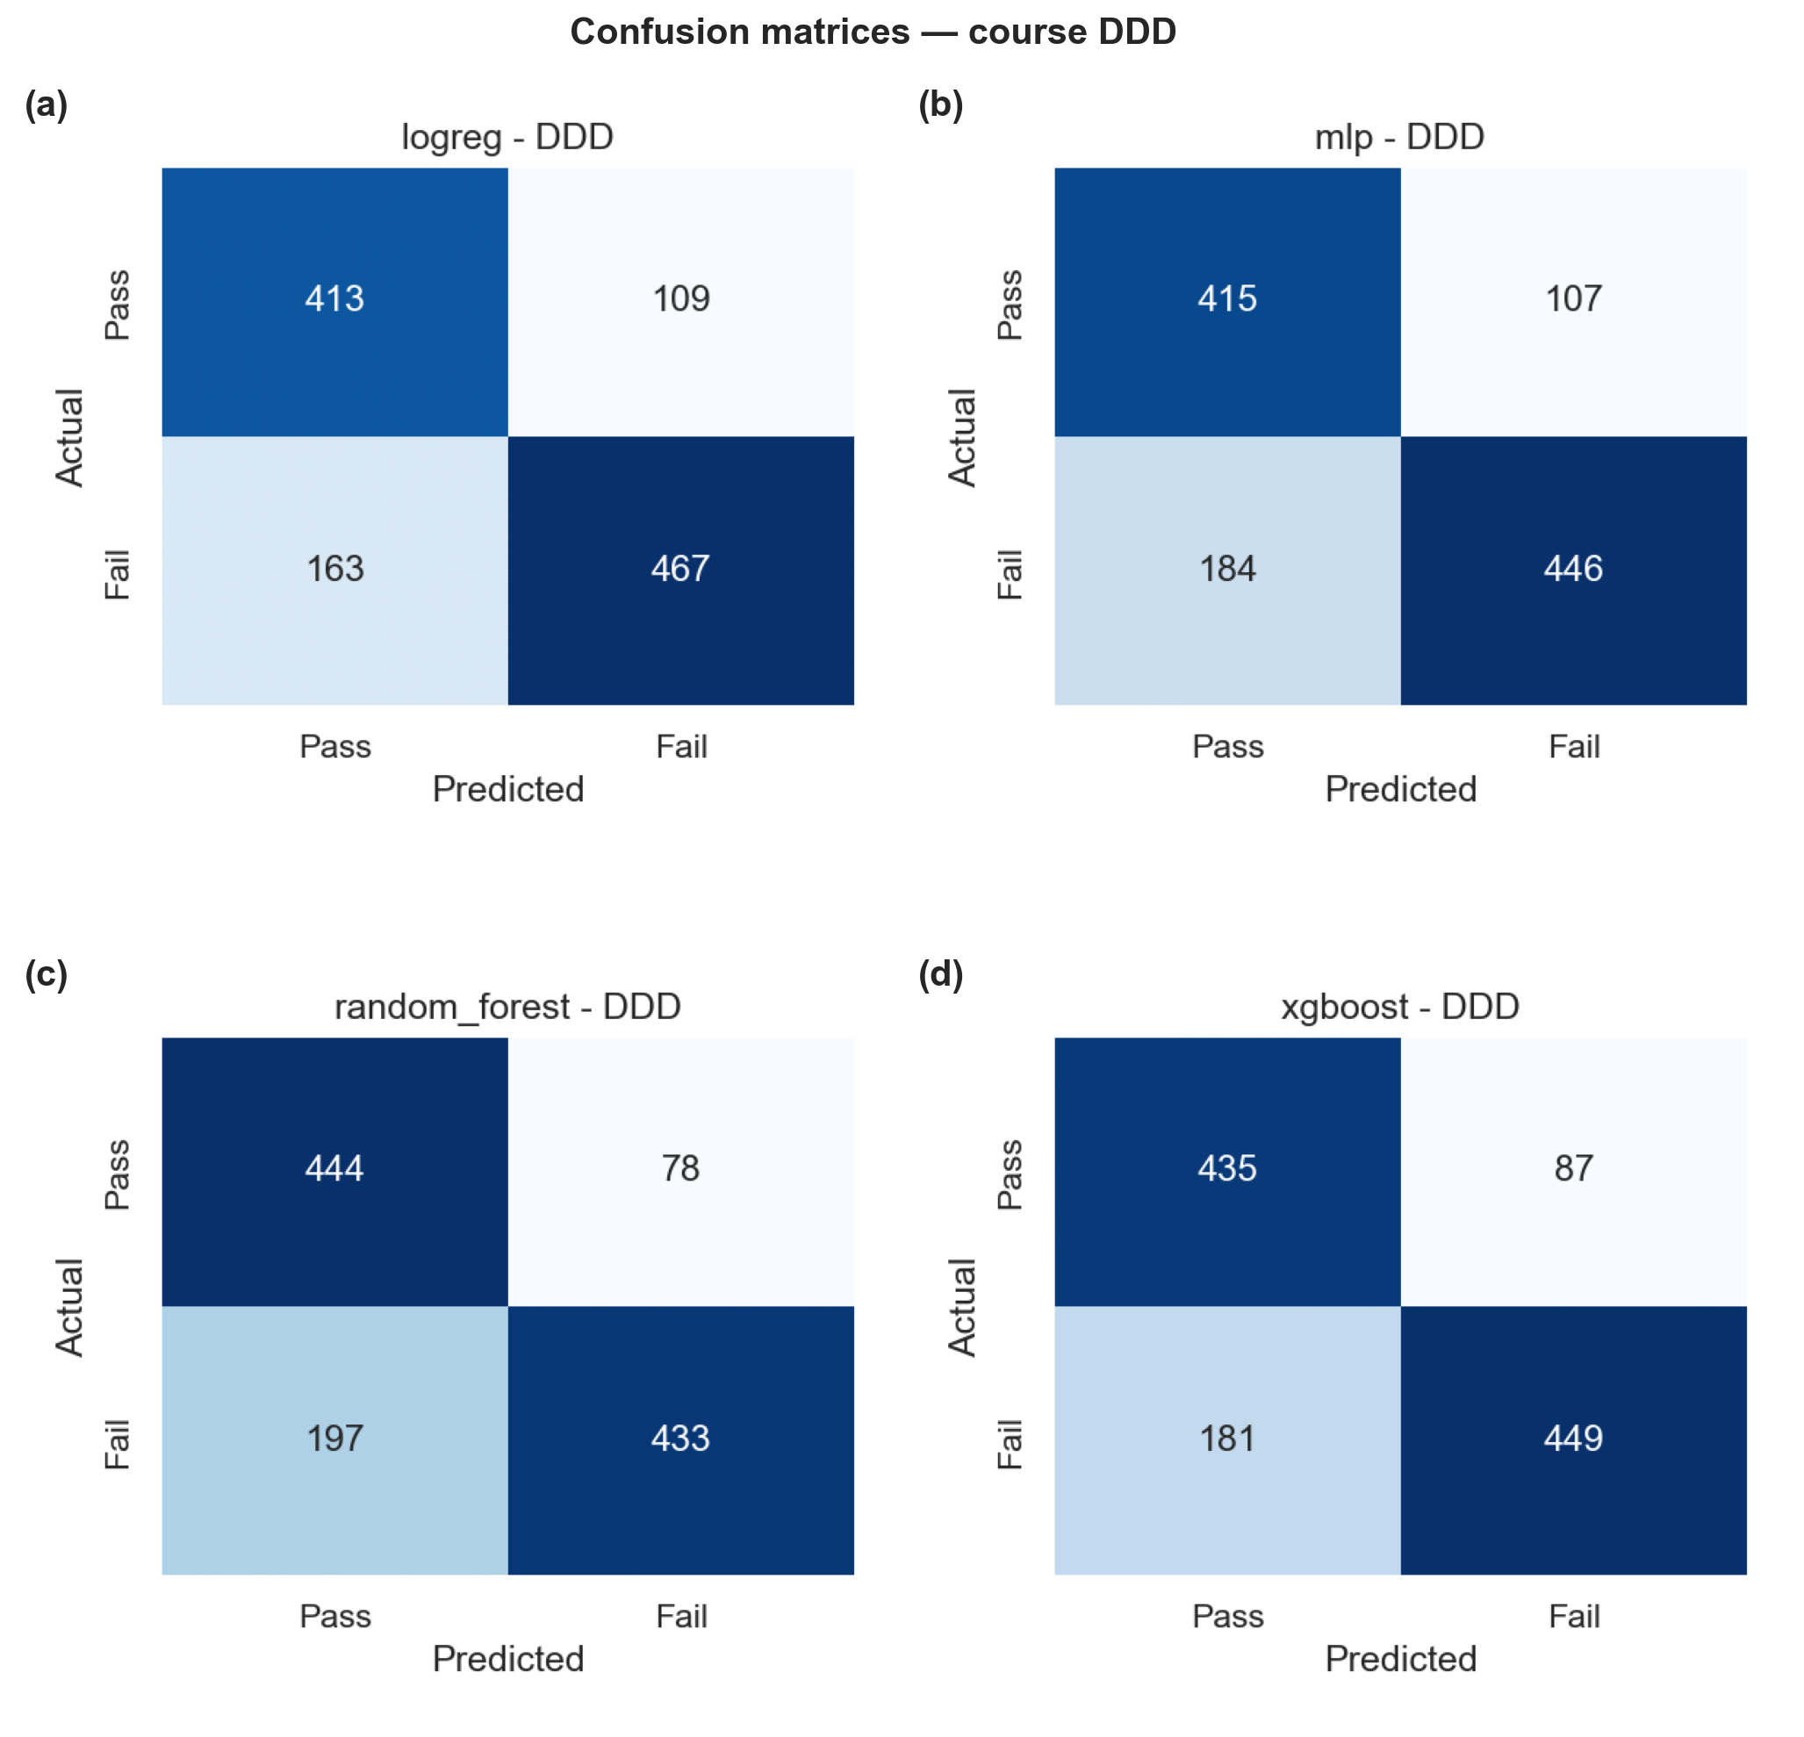Figure 5: Confusion matrices for the four models on course DDD.

3.3 Reliability
Cross-validation variance was small, supporting the reliability of these estimates. On DDD, cross-validated PR-AUC standard deviations were about ±0.008 to ±0.014, so the roughly 0.02 spread between models exceeds fold-to-fold noise and the ranking is meaningful. Held-out test scores were close to cross-validation means (for example, FFF XGBoost at 0.834 on both), indicating little overfitting.

3.4 Global drivers of risk
SHAP rankings on DDD placed the first-assessment mark as clearly the strongest driver (mean absolute SHAP about 0.178), well ahead of a second tier of engagement and background features around 0.023 to 0.026, including active-day ratio, distinct sites, early-submission timing and lower prior education (Figure 6). The picture was similar across courses: on BBB, the not-submitted indicator led; on EEE and FFF, the first-assessment mark. The ranking is a hierarchy rather than a single dominant feature, with several engagement measures carrying substantial weight beneath the first-assessment signal, which the ablation in Section 3.6 quantifies.
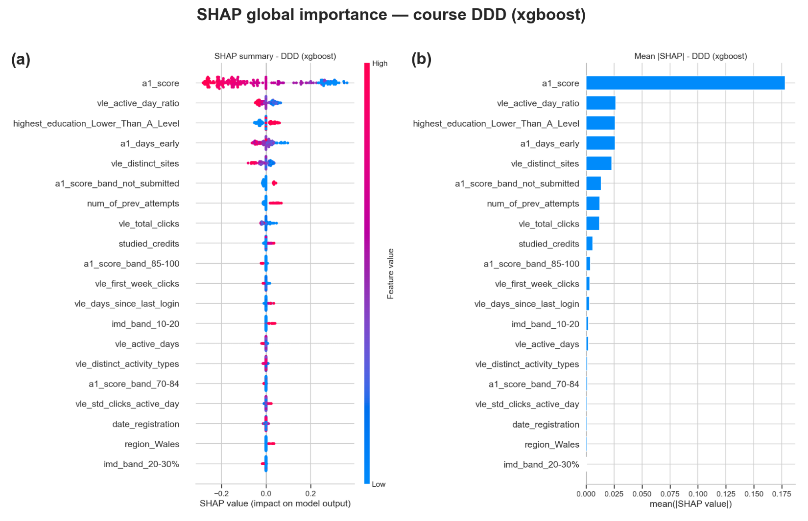Figure 6: Global SHAP feature importance for the best model on course DDD, showing the beeswarm summary (left) and mean absolute SHAP bar chart (right).

3.5 Individual explanations
Individual SHAP waterfall plots made the model's reasoning legible for a single student (Figures 7 and 8). For a correctly identified at-risk student, a low or missing first-assessment mark and weak early engagement combined to push predicted risk well above the base rate. For a false positive, otherwise-adverse features outweighed genuine engagement. For a false negative, strong early signals masked an eventual failure. This case-level transparency lets a tutor act on a flag and recognise when the model is likely wrong.

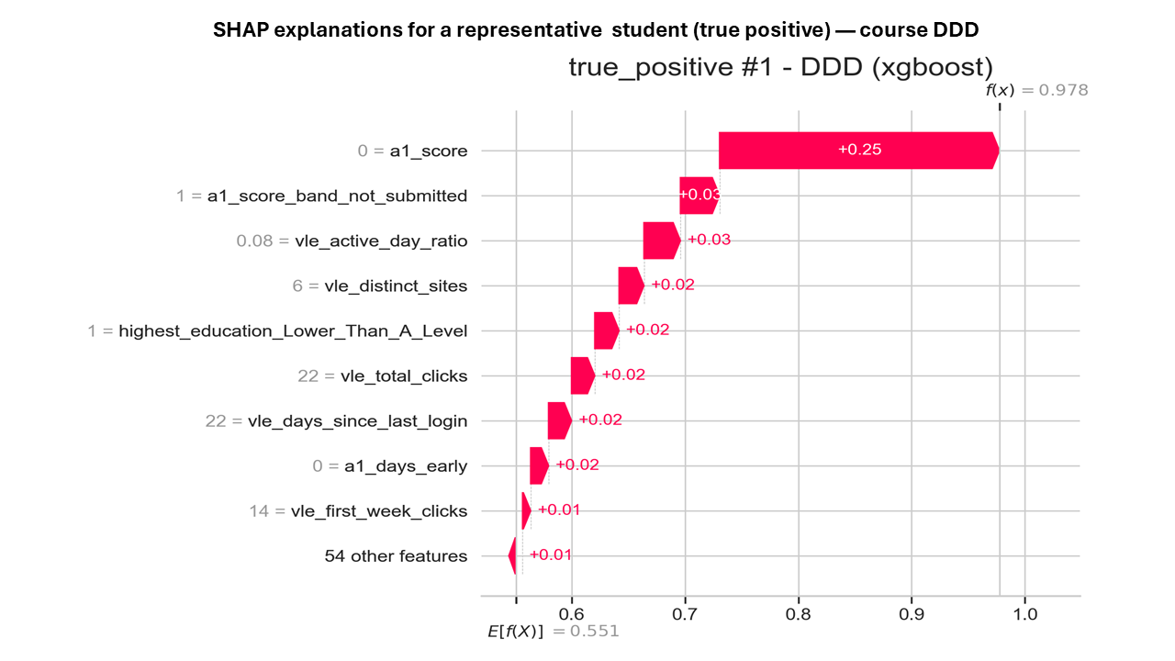Figure 7: SHAP waterfall explanations for a representative student on course DDD: a true positive.

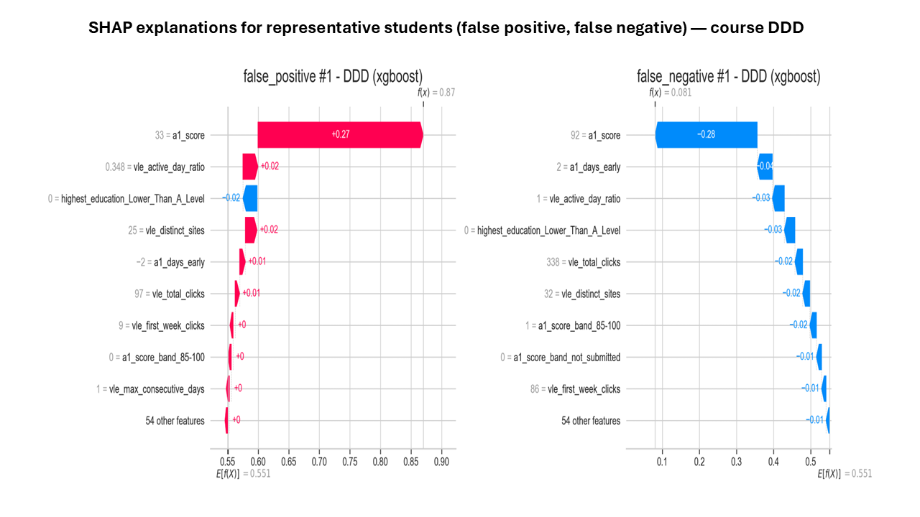
Figure 8: SHAP waterfall explanations for representative students on course DDD: a false positive (left) and a false negative (right).

3.6 Cross-course generalisation and ablation
Cross-course transfer was partial (Figure 9). Transferring a model (XGBoost) between courses resulted in PR-AUC falling to between 0.72 and 0.87. Transfer into DDD, EEE and FFF was stronger (0.81-0.87) than into BBB (0.72-0.78), so a single shared model is feasible, but course-specific calibration is still needed. The SHAP consistency check pointed the same way: four features (early-submission timing, the first-assessment mark, active-day ratio and total clicks) appeared in the top ten of all four courses, with several more recurring in two or three (Table 4), indicating a stable hierarchy of drivers even where absolute performance varies.
Table 4: Cross-course SHAP consistency: number of the four courses placing each feature in its top ten by mean absolute SHAP (features appearing in at least two courses shown).
Feature | Courses with features in top 10
a1_days_early | 4
a1_score | 4
vle_active_day_ratio | 4
vle_total_clicks | 4
a1_submitted | 3
highest_education_Lower_Than_A_Level | 3
num_of_prev_attempts | 2
a1_score_band_not_submitted | 2
vle_distinct_sites | 2
vle_max_clicks_day | 2
vle_distinct_activity_types | 2
vle_active_days | 2

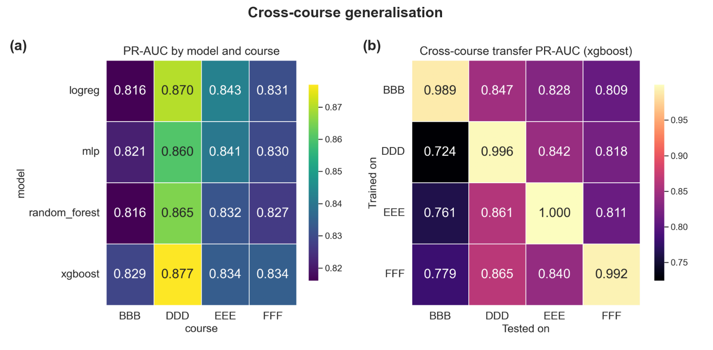Figure 9: Cross-course generalisation, showing within-course PR-AUC by model and course (left) and the XGBoost train-on-one, test-on-others transfer matrix (right).

A controlled ablation withheld the first-assessment mark and its banded form from every model, keeping submission behaviour and all engagement features. Performance fell only slightly: best-model PR-AUC dropped from 0.829, 0.877, 0.843 and 0.834 to 0.815, 0.845, 0.836 and 0.821 on BBB, DDD, EEE and FFF, a mean reduction of about 0.017 (Table 5). Withholding the single strongest predictor therefore barely dented performance, which shows that engagement and submission behaviour carry most of the early-warning signal in their own right.
Table 5: Ablation comparison of best-model PR-AUC with and without the first-assessment mark (XGBoost best across all modules without mark).
Module | Full model PR-AUC | No-A1-mark PR-AUC | Change (Δ)
BBB | 0.829 | 0.815 | −0.014
DDD | 0.877 | 0.845 | −0.032
EEE | 0.843 | 0.836 | −0.007
FFF | 0.834 | 0.821 | −0.014
Mean | 0.846 | 0.829 | −0.017

4. Discussion

4.1 Predictive accuracy (RQ1)
Failure could be well predicted from data available at the first-assessment checkpoint, with the best model reaching PR-AUC 0.877 on DDD and 0.829-0.877 across modules. Comparison with prior OULAD work needs care, since studies differ in horizon and metric. Oyedotun et al. (2025) report a ROC-AUC of about 0.79 using whole-course engagement with particular interest in Total VLE clicks, and the models here reach ROC-AUC 0.80-0.86 at a stricter, leakage-safe early horizon. Comparisons with higher headline numbers are less direct: Aljohani et al. (2019) and Gupta et al. (2022) report higher headline figures still, around 90% accuracy and AUC above 0.92 respectively, but both draw on later windows in the course, and accuracy and PR-AUC answer different questions on a near-balanced problem. Read against these differences in horizon and metric, the results are competitive and obtained at a point where a warning can still change the outcome. The most useful finding for RQ1 is not the peak score but the narrow spread: the four families sit within about 0.02 PR-AUC, and the neural network, the most complex, never won. This matches the documented pattern that tree ensembles are hard to beat on modest tabular data, where added neural complexity brings little gain (Grinsztajn et al., 2022; Shwartz-Ziv & Armon, 2022). The implication is concrete: the interpretable logistic regression model was within 0.02 of the best everywhere and won on EEE, so an institution could deploy the simpler, more transparent model at negligible loss in performance, a favourable trade-off for a tool that must be explained to tutors.

4.2 Drivers of risk and the role of the first mark (RQ2)
SHAP identified the first-assessment mark and early-submission behaviour as the leading drivers, with engagement measures close behind and demographic attributes largely secondary. This echoes Oyedotun et al. (2025) and Adnan et al. (2021), who both found assessment and engagement more predictive than demographics, and it is consistent with the earlier observation of Saqr et al. (2017) that consistency of engagement is among the strongest early predictors of underachievement. The ablation sharpens the finding beyond what SHAP alone can show. SHAP attributes importance within the fitted model, and because the first-assessment features are correlated, the mark, whether it was submitted, and its banded form share importance rather than holding it independently; reading the global ranking alone could therefore over- or under-state how much the mark truly contributes. Removing it entirely and re-fitting is the cleaner test, and the mean PR-AUC penalty of only about 0.017 shows the model is not merely restating the first grade. This matters in practice, because the mark exists only once the first assessment is in, whereas engagement accrues continuously, so a system that leans on behaviour could in principle warn even earlier than the horizon used here. Working on OULAD, Opoku et al. (2025) show that standard models can still carry demographic bias that only an explicit audit reveals, and that it can be mitigated at little cost to accuracy. The stakes are practical: Bird et al. (2025) show that when a biased model targets support, fewer of the marginalised students it is meant to help actually receive it. The fact that demographic attributes contribute little reduces the risk that predictions simply track protected characteristics; though it is not a guarantee: engagement itself can act as a proxy for circumstance, and the raw failure-rate gaps by deprivation and prior education (Section 3.1) are real and would need monitoring in any deployment.

4.3 Generalisation across courses (RQ3)
Transfer was partial: strong within a course, weaker but still useful across courses at 0.72-0.87, and better into some than others. The asymmetry is informative. Transfer into BBB was weakest, fitting its earlier, more variable first-assessment cutoff (as low as day 12) and suggesting its early-engagement dynamics differ. That the same four features recur in the top ten of every course indicates the underlying behavioural hierarchy is stable even where the fitted decision surface is not. This extends Dai et al. (2025), who found transfer across presentations of one course, to the harder case of different courses, where the result is a qualified yes. The distinction worth drawing separates two senses of generalisation easily conflated: stable feature importance does not imply a transferable model. A model can rank drivers similarly across courses yet still miscalibrate when moved, which is why the practical recommendation is a shared feature set with per-course calibration rather than one model applied everywhere.

4.4 Implications
For practice, the results support an interpretable early-warning tool that flags at-risk students around the first assessment and gives tutors a per-student explanation to act on. The competitiveness of the linear model and the small ablation penalty point the same way: a transparent, engagement-aware model is a defensible basis for intervention, functioning as decision support with a tutor in the loop rather than an automated gate. Accurate prediction is only half the problem, however. Evidence that early-warning systems improve outcomes is mixed: some link them to higher retention (Villano et al., 2018), while a Dutch field experiment found that early warning system-assisted counselling did not improve dropout or academic performance (Plak et al., 2022), and a cluster-randomised trial similarly found no significant effect on completion (Sletten et al., 2023). What separates success from null results appears to be the intervention attached to the flag rather than the flag itself: Chang et al. (2025) paired predictions with a tailored, culturally responsive intervention and saw most at-risk students reach a passing grade. An accurate model is therefore necessary but not sufficient; its value depends on the support it triggers. Reporting risk by demographic group also lets an institution check whether support reaches the groups with higher failure rates, turning a potential source of bias into a monitoring signal.

4.5 Limitations
Several limitations qualify these findings. The target conflates failure with post-census withdrawal, which may have different causes (Kocsis & Molnár, 2025). SMOTE can distort categorical variables because interpolation in encoded feature space may not preserve their true meaning (Mukherjee & Khushi, 2021). SHAP attributions reflect association within the model rather than causation (Salih et al., 2025) and depend on the chosen background set (García-Céspedes et al., 2025), so they explain the model, not the world. The horizon is a single checkpoint rather than a rolling weekly prediction, and because the cutoff day varies by course (12 to 33), the meaning of early is not perfectly uniform. Finally, all data comes from one institution, so external validity is untested, and the results, though stable under cross-validation, rest on a single test split per course.

4.6 Future work
Four extensions follow. Rolling weekly predictions, rather than a single checkpoint, would show how early reliable warning is possible and how risk evolves. Pooling courses and testing on an entirely held-out course would establish how far a single shared model can travel. A formal fairness audit, going beyond group failure rates to a differential-accuracy measure such as the Absolute Between-ROC Area (Gardner et al., 2019), would strengthen the equity case before deployment. Most importantly, given the mixed evidence above, an early-warning system's value is realised only through intervention, so a controlled trial linking flags to tutor action is the necessary next step.

5. Conclusion
This project built and evaluated an interpretable, leakage-safe pipeline for predicting distance-learning failure at the first-assessment checkpoint. Across four OULAD modules, the best model reached a held-out PR-AUC of 0.829-0.877, with an interpretable linear model within 0.02 throughout and cross-validation variance small enough to make the model ranking meaningful. SHAP showed that first-assessment behaviour and VLE engagement drive predicted risk while demographics contribute little, and an ablation showed engagement alone retains most of the signal; the first-assessment mark was worth only about 0.017 PR-AUC on average. Transfer across courses was partial, but the leading drivers were stable, pointing to a shared feature set with per-course calibration. These results support accurate, explainable and reasonably general early identification of at-risk students, while making clear that per-course validation and a real intervention study are the next steps toward deployment.

References
Adnan, M., Habib, A., Ashraf, J., Mussadiq, S., Raza, A.A., Abid, M., Bashir, M. and Khan, S.U. (2021) ‘Predicting at-risk students at different percentages of course length for early intervention using machine learning models’, IEEE Access, 9, pp. 7519–7539. https://doi.org/10.1109/ACCESS.2021.3049446
Akçapınar, G., Altun, A. and Aşkar, P. (2019) ‘Using learning analytics to develop early-warning system for at-risk students’, International Journal of Educational Technology in Higher Education, 16, 40. https://doi.org/10.1186/s41239-019-0172-z
Aljohani, N.R., Fayoumi, A. and Hassan, S.-U. (2019) ‘Predicting at-risk students using clickstream data in the virtual learning environment’, Sustainability, 11(24), 7238. https://doi.org/10.3390/su11247238
Bird, K.A., Castleman, B.L. and Song, Y. (2025) ‘Are algorithms biased in education? Exploring racial bias in predicting community college student success’, Journal of Policy Analysis and Management, 44(2), pp. 379–402. https://doi.org/10.1002/pam.22569
Breiman, L. (2001) ‘Random forests’, Machine Learning, 45, pp. 5–32. https://doi.org/10.1023/A:1010933404324
Chang, Y.-H., Chen, F.-C. and Lee, C.-I. (2025) ‘Developing an early warning system with personalized interventions to enhance academic outcomes for at-risk students in Taiwanese higher education’, Education Sciences, 15(10), 1321. https://doi.org/10.3390/educsci15101321
Chawla, N.V., Bowyer, K.W., Hall, L.O. and Kegelmeyer, W.P. (2002) ‘SMOTE: synthetic minority over-sampling technique’, Journal of Artificial Intelligence Research, 16, pp. 321–357. https://doi.org/10.1613/jair.953
Chen, T. and Guestrin, C. (2016) ‘XGBoost: a scalable tree boosting system’, in Proceedings of the 22nd ACM SIGKDD International Conference on Knowledge Discovery and Data Mining (KDD ’16). New York: Association for Computing Machinery (ACM), pp. 785–794. https://doi.org/10.1145/2939672.2939785
Dai, W., Lin, J., Jin, F.J.-Y., Tsai, Y.-S., Srivastava, N., Le Bodic, P., Gašević, D. and Chen, G. (2025) ‘Learning analytics for early identification of at-risk students and feedback intervention’, Journal of Learning Analytics, 12(3), pp. 102–125. https://doi.org/10.18608/jla.2025.8735
García-Céspedes, R., Alias-Carrascosa, F.J. and Moreno, M. (2025) ‘On machine learning models explainability in the banking sector: the case of SHAP’, Journal of the Operational Research Society, 76(12), pp. 2591–2603. https://doi.org/10.1080/01605682.2025.2485263
Gardner, J., Brooks, C. and Baker, R.S. (2019) ‘Evaluating the fairness of predictive student models through slicing analysis’, in Proceedings of the 9th International Conference on Learning Analytics & Knowledge (LAK19). New York: Association for Computing Machinery (ACM), pp. 225–234. https://doi.org/10.1145/3303772.3303791
Grinsztajn, L., Oyallon, E. and Varoquaux, G. (2022) ‘Why do tree-based models still outperform deep learning on typical tabular data?’, in Advances in Neural Information Processing Systems 35. Red Hook, NY: Curran Associates, pp. 507–520. https://doi.org/10.52202/068431-0037
Gupta, A., Garg, D. and Kumar, P. (2022) ‘Mining sequential learning trajectories with hidden Markov models for early prediction of at-risk students in e-learning environments’, IEEE Transactions on Learning Technologies, 15(6), pp. 783–797. https://doi.org/10.1109/TLT.2022.3197486
Jin, L., Wang, Y., Song, H. and So, H.J. (2024) ‘Predictive modelling with the Open University Learning Analytics Dataset (OULAD): a systematic literature review’, in Olney, A.M., Chounta, I.A., Liu, Z., Santos, O.C. and Bittencourt, I.I. (eds) Artificial Intelligence in Education. Posters and Late Breaking Results, Workshops and Tutorials, Industry and Innovation Tracks, Practitioners, Doctoral Consortium and Blue Sky. AIED 2024. Communications in Computer and Information Science, 2150. Cham: Springer, pp. 477–484. https://doi.org/10.1007/978-3-031-64315-6_46
Kocsis, Á. and Molnár, G. (2025) ‘Factors influencing academic performance and dropout rates in higher education’, Oxford Review of Education, 51(3), pp. 414–432. https://doi.org/10.1080/03054985.2024.2316616
Kuzilek, J., Hlosta, M. and Zdrahal, Z. (2017) ‘Open University Learning Analytics dataset’, Scientific Data, 4, 170171. https://doi.org/10.1038/sdata.2017.171
Levy, Y. (2007) ‘Comparing dropouts and persistence in e-learning courses’, Computers & Education, 48(2), pp. 185–204. https://doi.org/10.1016/j.compedu.2004.12.004
Lundberg, S.M. and Lee, S.-I. (2017) ‘A unified approach to interpreting model predictions’, in Advances in Neural Information Processing Systems 30. Red Hook, NY: Curran Associates, pp. 4765–4774.
Mukherjee, M. and Khushi, M. (2021) ‘SMOTE-ENC: A novel SMOTE-based method to generate synthetic data for nominal and continuous features’, Applied System Innovation, 4(1), 18. https://doi.org/10.3390/asi4010018
Opoku, R.A., Pei, B. and Xing, W. (2025) ‘Unveiling accuracy-fairness trade-offs: investigating machine learning models in student performance prediction’, Journal of Learning Analytics, 12(2), pp. 125–139. https://doi.org/10.18608/jla.2025.8543
Oyedotun, S.A., Ejenarhome, O.P. and Oise, G.P. (2025) ‘Learning analytics and predictive modeling: enhancing student success through data-driven insights’, Journal of Science Research and Reviews, 2(3), pp. 42–51. https://doi.org/10.70882/josrar.2025.v2i3.77
Pedregosa, F., Varoquaux, G., Gramfort, A., Michel, V., Thirion, B., Grisel, O., Blondel, M., Prettenhofer, P., Weiss, R., Dubourg, V., Vanderplas, J., Passos, A., Cournapeau, D., Brucher, M., Perrot, M. and Duchesnay, É. (2011) ‘Scikit-learn: machine learning in Python’, Journal of Machine Learning Research, 12(85), pp. 2825–2830.
Plak, S., Cornelisz, I., Meeter, M. and van Klaveren, C. (2022) ‘Early warning systems for more effective student counselling in higher education: evidence from a Dutch field experiment’, Higher Education Quarterly, 76(1), pp. 131–152. https://doi.org/10.1111/hequ.12298
Rahmani, A.M., Groot, W. and Rahmani, H. (2024) ‘Dropout in online higher education: a systematic literature review’, International Journal of Educational Technology in Higher Education, 21, 19. https://doi.org/10.1186/s41239-024-00450-9
Sahlaoui, H., Alaoui, E.A.A., Nayyar, A., Agoujil, S. and Jaber, M.M. (2021) ‘Predicting and interpreting student performance using ensemble models and Shapley additive explanations’, IEEE Access, 9, pp. 152688–152703. https://doi.org/10.1109/ACCESS.2021.3124270
Saito, T. and Rehmsmeier, M. (2015) ‘The precision-recall plot is more informative than the ROC plot when evaluating binary classifiers on imbalanced datasets’, PLOS ONE, 10(3), e0118432. https://doi.org/10.1371/journal.pone.0118432
Salih, A.M., Raisi-Estabragh, Z., Galazzo, I.B., Radeva, P., Petersen, S.E., Lekadir, K. and Menegaz, G. (2025) ‘A perspective on explainable artificial intelligence methods: SHAP and LIME’, Advanced Intelligent Systems, 7(1), 2400304. https://doi.org/10.1002/aisy.202400304
Saqr, M., Fors, U. and Tedre, M. (2017) ‘How learning analytics can early predict under-achieving students in a blended medical education course’, Medical Teacher, 39(7), pp. 757–767. https://doi.org/10.1080/0142159X.2017.1309376
Shwartz-Ziv, R. and Armon, A. (2022) ‘Tabular data: deep learning is not all you need’, Information Fusion, 81, pp. 84–90. https://doi.org/10.1016/j.inffus.2021.11.011
Sletten, M.A., Tøge, A.G. and Malmberg-Heimonen, I. (2023) ‘Effects of an early warning system on student absence and completion in Norwegian upper secondary schools: a cluster-randomised study’, Scandinavian Journal of Educational Research, 67(7), pp. 1151–1165. https://doi.org/10.1080/00313831.2022.2116481
Villano, R., Harrison, S., Lynch, G. and Chen, G. (2018) ‘Linking early alert systems and student retention: a survival analysis approach’, Higher Education, 76, pp. 903–920. https://doi.org/10.1007/s10734-018-0249-y

